Institute of Technology Tallaght
Department of Computing

National Diploma in Computing

Operating Systems
Memory Management

- The allocation of main memory to processes in a contiguous memory system using variable partition multiprogramming is shown in this diagram:

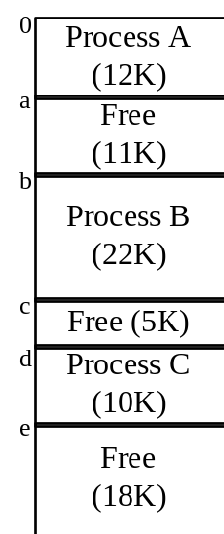

- Show the final Free Storage List and how it would be maintained under each of the following placement strategies: First-fit, Best-fit, Worst-Fit for the following events :
- Process D arrives requesting 4K of memory

First-Fit:
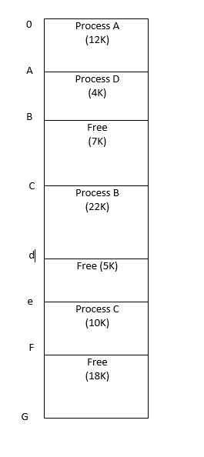

Best-Fit:
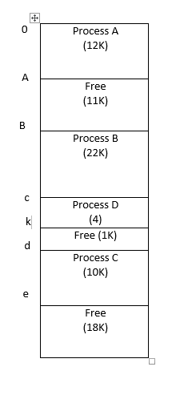

Worst-Fit:
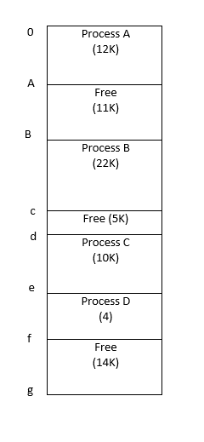
- Process D arrives, requesting 15K of memory, and

First-Fit:
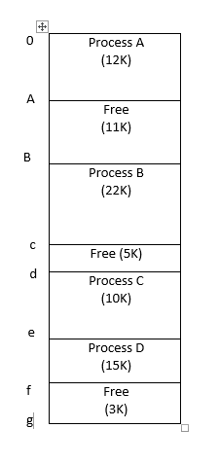

Best-Fit:

Worst-Fit:
(3) Process C terminates.
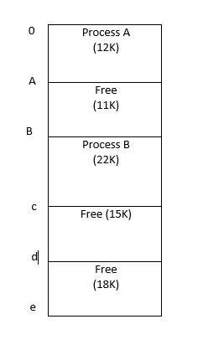

2. Consider a contiguous allocation variable partition multiprogramming system, which contains the following holes (in order): 128K, 512K, 256K, and 622K. Processes A, B, C, and D arrive in order and request 212K, 417K, 112K and 426K respectively.
Show how the best fit, worst fit, and first fit algorithms would place these processes.
First-Fit:
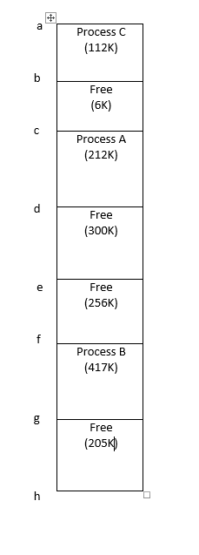

Which makes best use of memory in this case?
- Consider a Page Based Operating System that uses Direct Mapping. The pages are 4 bytes in size. The CPU requests virtual address

3 | 2

The Page Map Table and Physical Memory (divided into Page Frames) are shown to the right.

- What do the “3” and “2” in the virtual address represent?
- What data will be retrieved by this request? Draw a diagram showing how the real address is computed.

- A combined associative/direct mapping paging system has a hit ratio of 80%. It takes 20nS to access the Associative Storage, and 100nS to access real storage. On average, how long will it take to access a page in memory?

Page Map Table Physical Memory
 | 5 |  |  | 0 | a
 | 6 |  |  |  | t
 | 1 |  |  |  | h
 | 2 |  |  |  | w
 | 7 |  |  | 1 | e
 |  |  |  |  | i
 |  |  |  |  | p
 |  |  |  |  | o
 |  |  |  | 2 | q
 |  |  |  |  | n
 |  |  |  |  | l
 |  |  |  |  | m
 |  |  |  | 3 | e
 |  |  |  |  | i
 |  |  |  |  | p
 |  |  |  |  | o
 |  |  |  | 4 | q
 |  |  |  |  | l
 |  |  |  |  | m
 |  |  |  |  | a
 |  |  |  | 5 | q
 |  |  |  |  | l
 |  |  |  |  | m
 |  |  |  |  | a
 |  |  |  | 6 | e
 |  |  |  |  | i
 |  |  |  |  | p
 |  |  |  |  | o
 |  |  |  | 7 | q
 |  |  |  |  | l
 |  |  |  |  | m
 |  |  |  |  | a

